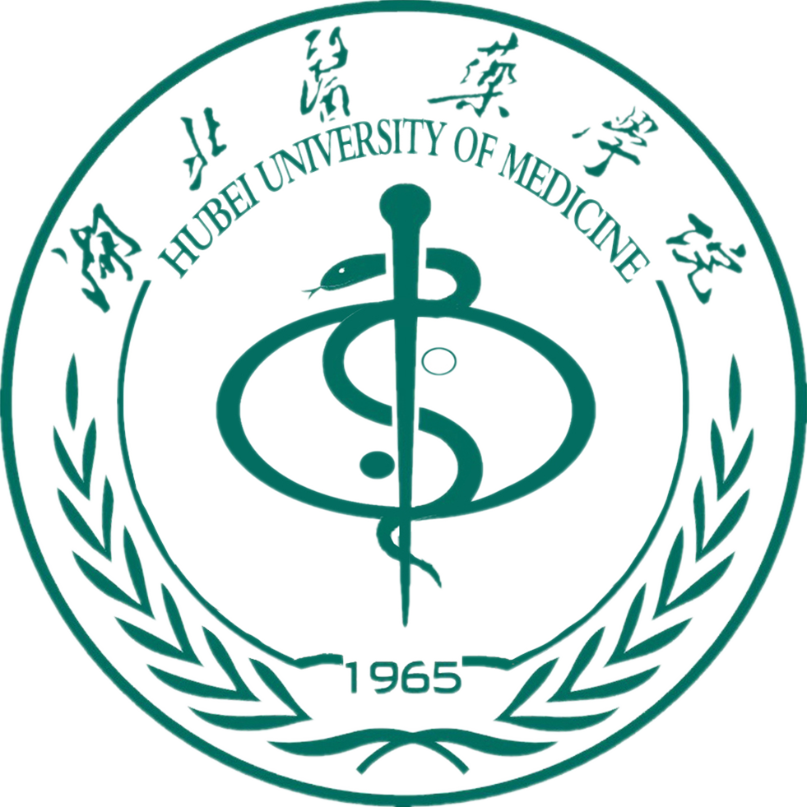
外国留学生入学申请表
Application Form for Foreign Students

本表格应该在完成后及时邮寄至中国湖北省十堰市人民南路30号湖北医药学院国际教育学院，442000
This application should be completed and returned without delay to the International School, Hubei University of Medicine, 30 South Renmin Road, Shiyan, Hubei, 442000 China

护照用名 姓  Personal Name Family Name |  |  |  |  |  | 照 片  （photo）
名  First Name |  |  |  |  |  | 照 片  （photo）
出生日期  Date of Birth 年/Yr. 月/Mon 日/Date |  | 出生地点/ Place of Birth |  |  |  | 照 片  （photo）
国籍/ Nationality |  | 性别/Sex □男/Male □女/Female |  |  |  | 照 片  （photo）
护照号码/ Passport No. |  | 宗教信仰/ Religion |  |  |  | 照 片  （photo）
职业/ Occupation : |  | 健康状况/ Health Status |  |  |  | 照 片  （photo）
婚姻/ Marital Status □已婚/ Married □未婚/ Single |  | 工作或学习单位/ Work or study unit:
本国通信地址及联系电话/ Mailing Address and Telephone in Applicant’s Country: |  |  |  |  | 电子邮件/ E-mail Address
本人最后学历/ Final Education Background:
□高中毕业生/ graduate from senior high school 10+2 SCIENCE |  |  | □大学在读/ current college student
□大学本科毕业/ graduate from college |  |  | □研究生/ postgraduate
你曾经学过汉语吗？/ Have you learned Chinese?  □是的/ Yes □没有/No  如果是你学了多少年？/ If yes, How many years? |  |  | 你曾经参加过HSK考试吗？/ Have you attended HSK?  □是的/Yes □没有/No  如果是你达到了几级/ If yes, what level did you get?
你申请攻读什么专业？/ What program do you apply for?
在湖北医药学院学习期限/ Duration of study at Hubei University of Medicine: 从/from 年/Yr 月/Mon. 至/to 年/Yr. 月/Mon.
在华事务联系人或机构/ Person or agency to act on your behalf in China

本国领事馆/ Home embassy  □上海/ Shanghai □北京/ Beijing | 其它机构或个人/ Other agency or person  机构名称或姓名/ Name :  地址或电话/ Address & Telephone:
在湖北医药学院学习期间住宿房间类型/ Options of Accommodation  at Hubei University of Medicine | □留学生公寓楼双人间/ Double room in international students accommodation |  |  | □留学生公寓楼单人/ Single room in international students accommodation

最后学历 主修专业 学 位 学 校
Final Education Major or Specialty Academic Degree Obtained Name of School

个人简历 起止时间 工作或学习单位 任 职
Resume Duration Work or Study Unit Type of Job
母语 会何种其它语言
Native language Proficiency of other languages
如果你是学历项目申请者，请填写以下内容/ If you apply for degree program, please full out the followings.
现在所学专业与今后工作的关系
The relation between present study and future career
专题研究内容或计划
Research topic and plan:
曾发表过的著作或论文题目
Publications

申请人保证： I hereby affirm that：
1、上述各项中所提供的情况是真实无误的。 1. All the information in this form is true and correct.
2、在中国学习期间遵守中国政府的法律和学校的规章制度 2. I shall abide by the laws of Chinese Government and regulations of university.
3、接受湖北医药学院对学习的安排。 3. I shall accept the arrangements of Hubei University of Medicine regarding my studies.

申请人签字: 日期:
Applicant’s signature: Date

